
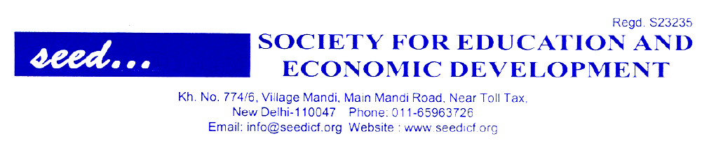

ICF celebrating 25 years of its existence – the silver Jubilee year
Subject: Election of Office Bearer of ICF for the year 2019-21
(1st August, 2019 to 31 July, 2021)

Dear Principal ICF Member College,

After the amendment of the Constitution (Amended Constitution of ICF is on www.seededu.org. Please download the same for your use.
After the amendment of Indian Colleges Forum second election of ICF Executive Committee was held in 2016-18. The list of Office Bearer elected through the process of postal ballet is available on www.seededu.org. The election of office bearers was for a period of two years i.e. 2018. But it was extended up to 31st July, 2019. This period is getting over by the end of 31st July, 2019. We are happy to announce the Election of Office Bearer of ICF for the period 2019-21- for a period of two years
Election Officer along with team of two senior persons have been appointed to receive ballot papers, process them and place the result before the President, SEED for declaring the result.
We are enclosing the a ballot paper for exercising your preference for the position of State Secretary and two more persons as a part of team of ICF executive committee at the state level. Method of exercising the choice would be three preferences by each member college principal. The college/principal getting the highest first preference would be appointed as State Secretary of ICF and those who get highest second and third preference will be appointed as member of State level ICF executive Committee. Preferences would be exercised in the form of college registration no. The state wise list of ICF member Colleges is on www.seededu.org website. You may please down load it for your convenience. Click at ICF in the list of centres and click at member. There is drop down list of state. Click at appropriate state to get the list.
Please send your preferences in sealed cover to Election officer. Latest by 15th July 2019 you can also send your preference choices by e- mail. Your choices will be kept confidential.
Looking forward to your enthusiastic participation and with best wishes
Yours Sincerely


(GD Sharma)
President, SEED

All ICF Member Colleges

Kh. No. 774/6, Mandi Village, Main Mandi Road Nera Mandi & Gorgon Border, New Delhi – 110047
Email-seedicf@gmail.com, Ph-011-26651196

